The accompanying PowerPoint presentation gives an overview of the primary components of the Fiscal Impact Analysis Model (FIAM). The model makes it possible to evaluate the fiscal feasibility of a future land use scenario for a local government over the planning horizon presented in the comprehensive plan.

The presentation shows the steps in the calculation of expenditures and revenues, once the land use consumption rates have been determined, in the following order:
- Capital Revenues
- Capital Costs
- Operating Costs
- Operating Revenues
- Combined Present Values

- Start with the blank initial slide, with just the title and legend. Explain the slide legend, which highlights the different types of tabs in the model. Then, explain the two basic approaches to generating the future land use scenario.

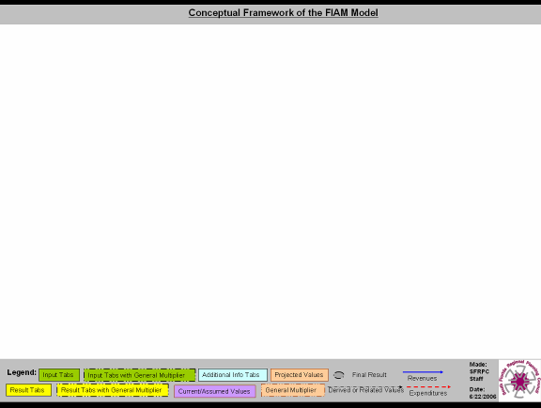

- Click 4 times to show the “Current Land Use,” “Future Land Use” and “Development” boxes. Pause, and explain that the FIAM model begins by using the growth rates for each detailed land use type to project the annual land use consumption by type over the planning horizon. It offers tools to estimate the land use consumption by detailed type based on projected population and employment growth if detailed land use growth rates are not known.

Then ask the question: What will be the revenues and expenditures for the local jurisdiction associated with this development?

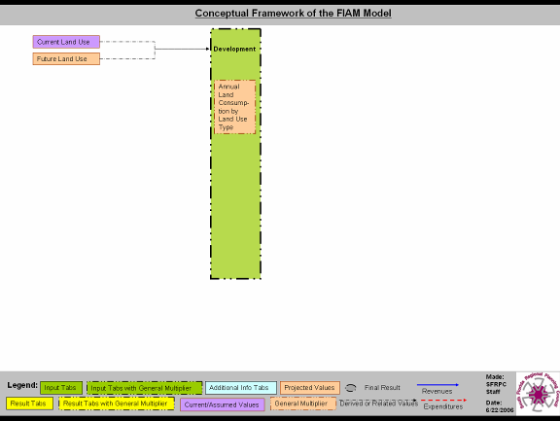

- The answer begins with the estimation of capital revenues. This can be accomplished by making assumptions about the impact fee schedule for each of the detailed land use types included in the development scenario. Click 3 times to show that impact fee assumptions are included on the Assumptions tab, which result in the calculation of annual impact fee accruals on the Impact Fees tab of the model.

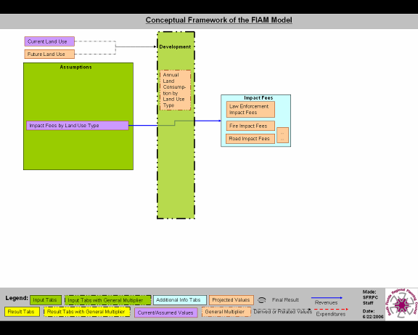

- Click 4 more times to show the flow from “Impact Fees” through the Capital Improvements Plan (“CIP”) to the “Capital Revenues” box on the “Summary” tab.

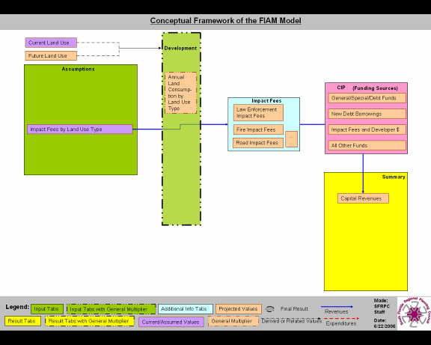

- With 2 more clicks, follow the same logic to show how assumptions about the capital costs associated with each detailed land use type, when applied to the Development scenario, lead to projected capital costs in the “Capital Costs” box. Make note of the fact that “Road Capital” costs will be shown separately.

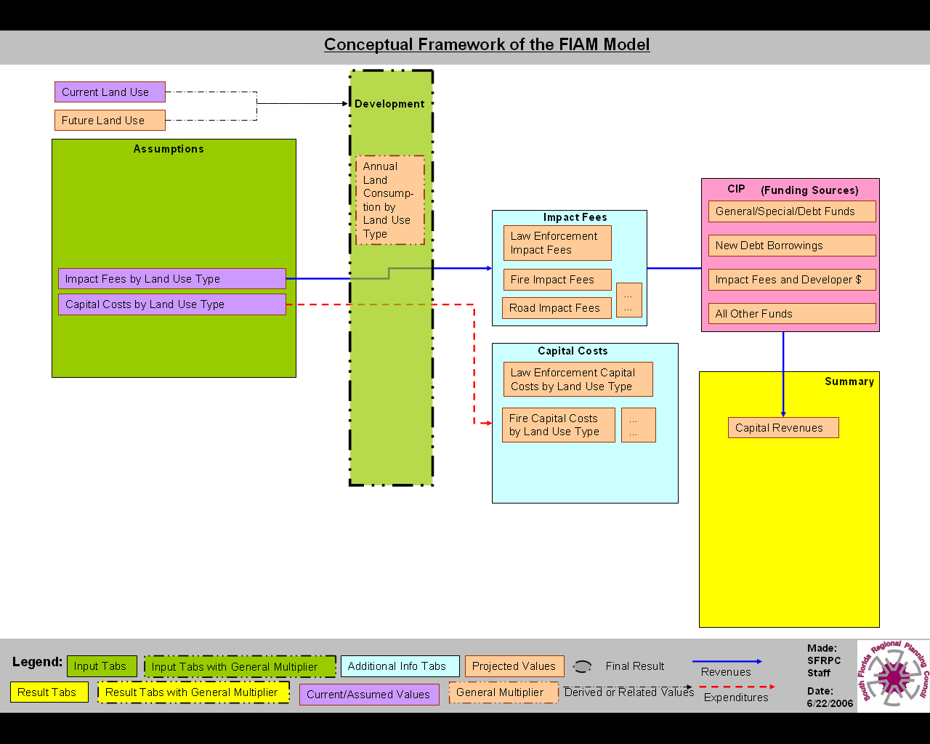

- Another 3 clicks show how the FIAM model provides a separate tab for Roads Capital cost assumptions, and then calculates the costs based on the specific land use scenario. These costs are added to other Capital Costs calculated in the previous step and are shown on the Summary tab. This completes the calculation of Capital Revenues and Capital Costs.

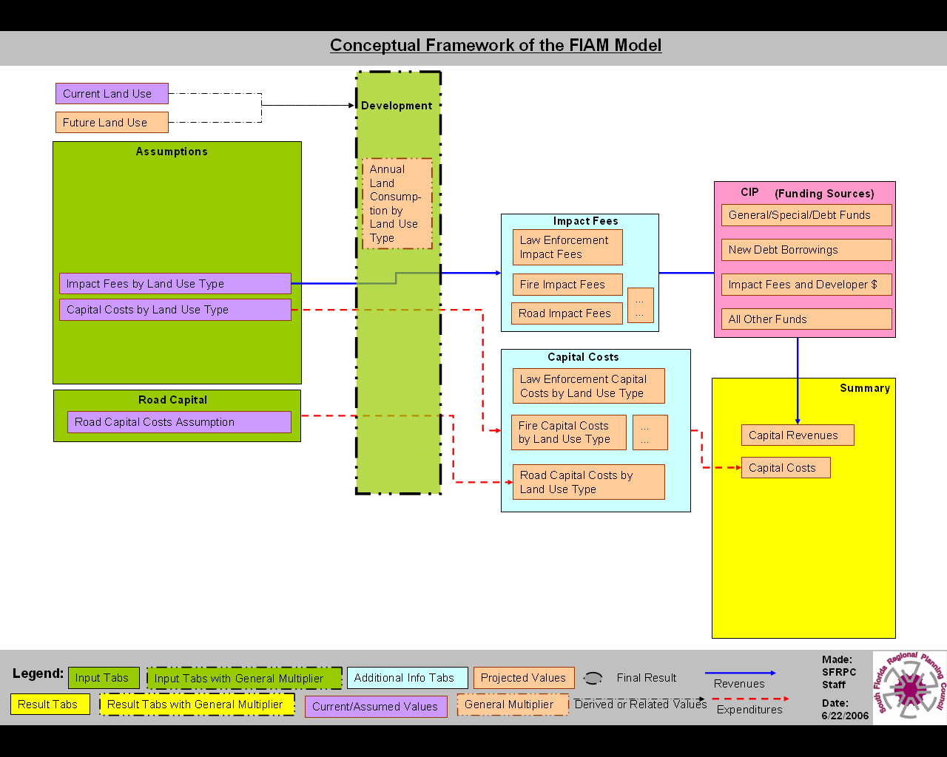

- Click once to clean all unnecessary boxes on the screen. Then click again to show the “Capital Revenues” and “Capital Costs” boxes and remind the audience that so far, we have calculated the Capital Revenues and Capital Costs. Click again to show two boxes (Operating Revenues and Operating Costs), and raise the question: How about the Operating Revenues and Costs? A final click removes those two boxes until we are ready to show where the information comes from.

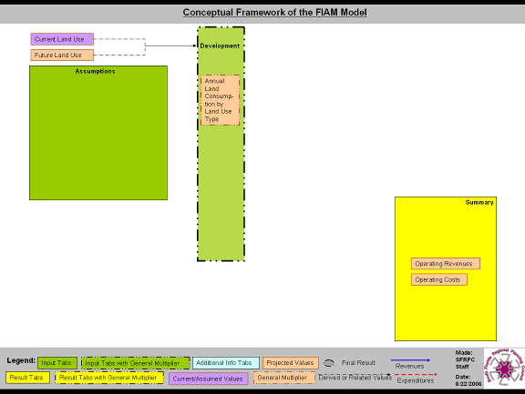

- Click twice to show the “Budget Input” and “Growth” boxes with just expenditure elements in them. These elements represent the baseline per capita expenditures and the annual growth rate of those expenditures by budget category. The Model calculates annual per capita expenditures based on a 10-year historical trend, but we still need to project the annual number of taxable people in order to project aggregate operating expenditures. So, how does the Model calculate this number for you?

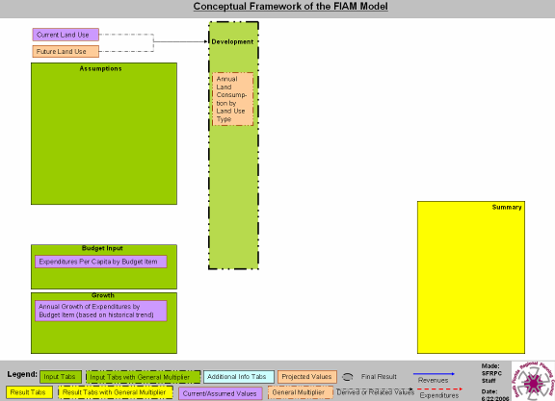

- Click twice to show the number of Residents, Employees (by Land Use Type) and Visitors, along with full-time equivalency factors in the “Assumption” tab.

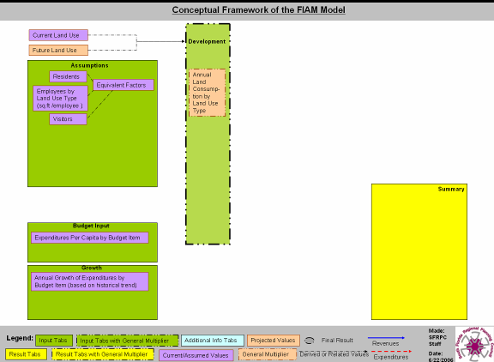

- Another 2 clicks will bring up the “Fiscal Output” box. Explain briefly how these assumptions about Residents, Employees, Visitors, and Equivalence Factors apply through the land use development scenario to generate the annual full-time equivalent population, employees and visitors profile for your community.

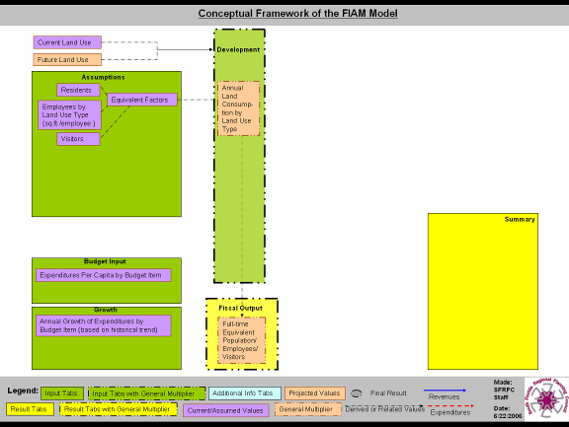

- Click twice more to show how the “Expenditures by Budget Item” are calculated through the three elements connected by the red arrow.

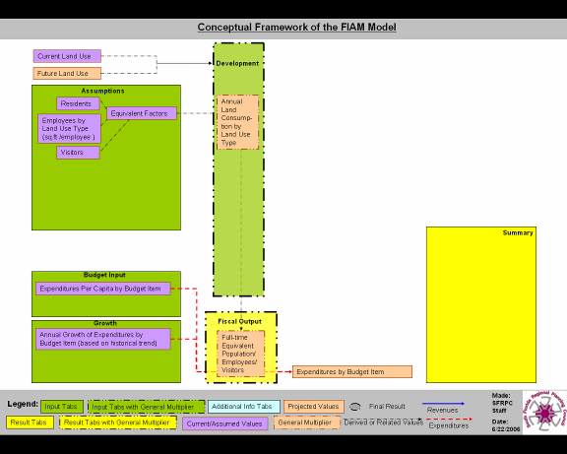

- Click twice more to show that Operating Costs are total projected expenditures based on the historical trend on per capita basis.

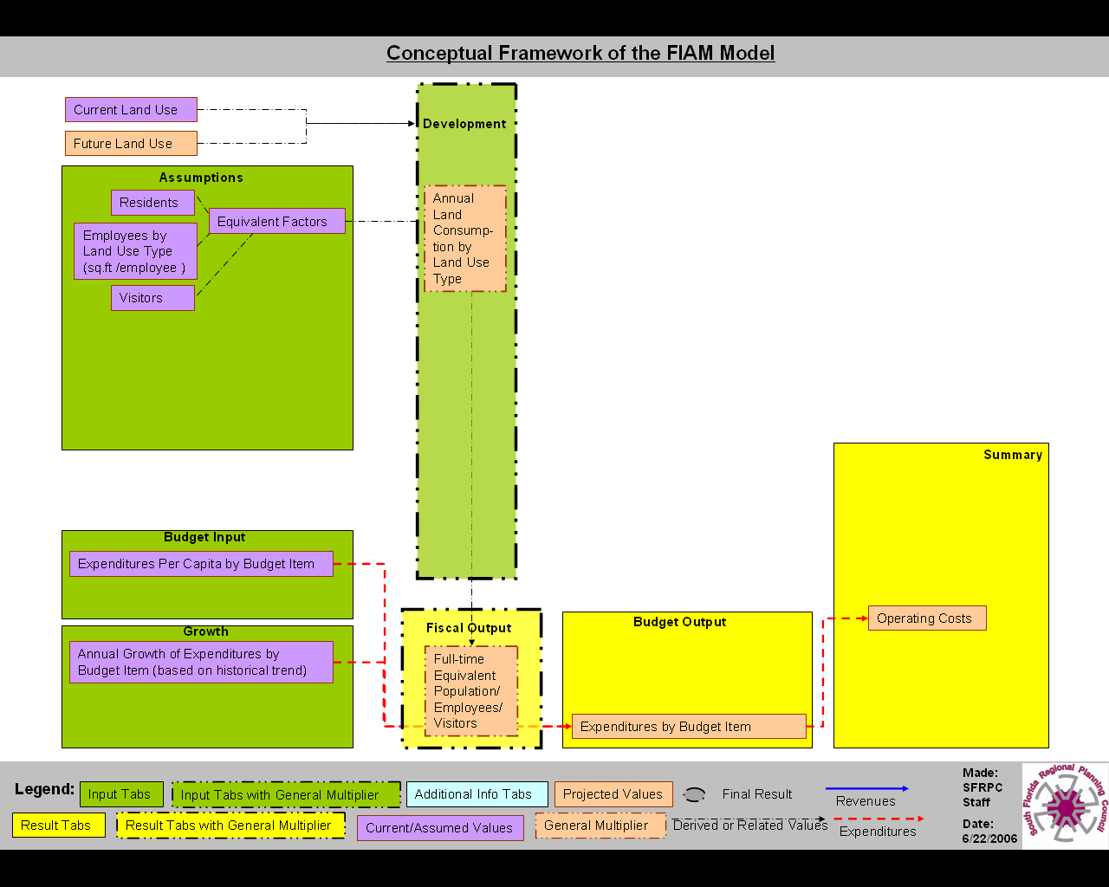

- Click to clean out the elements related to the expenditure side. Then click three times to show how Revenues by Budget Item are calculated in the Budget Output Tab, except for the Ad Valorem Taxes, which will be shown next.

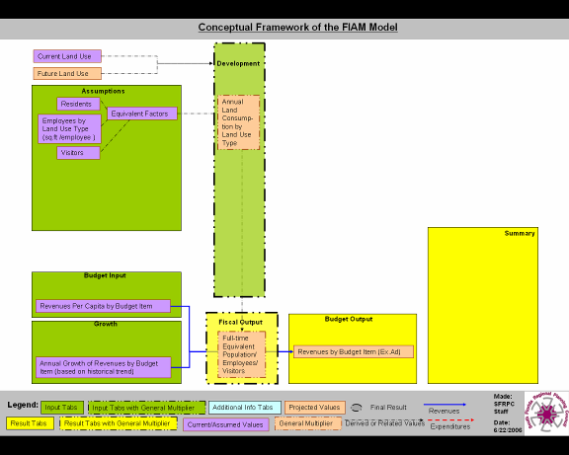

- Click three times to show how total Ad Valorem Taxes are calculated in the Model. As the blue arrow shows, it is the product of the assumed Property Values by Land Use Type, Millage Rates, and annual land use Development scenario.

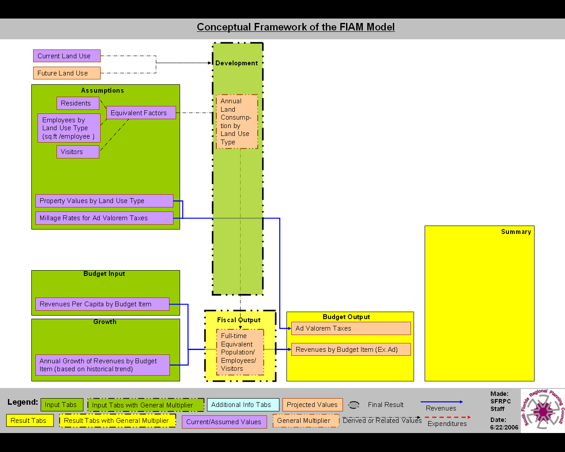

- Click twice to show how Operating Revenues are calculated in the Model. Operating Revenues are the residual of total projected revenues minus part of components of Capital Revenues (General/Special/Debt Funds and other Fund).

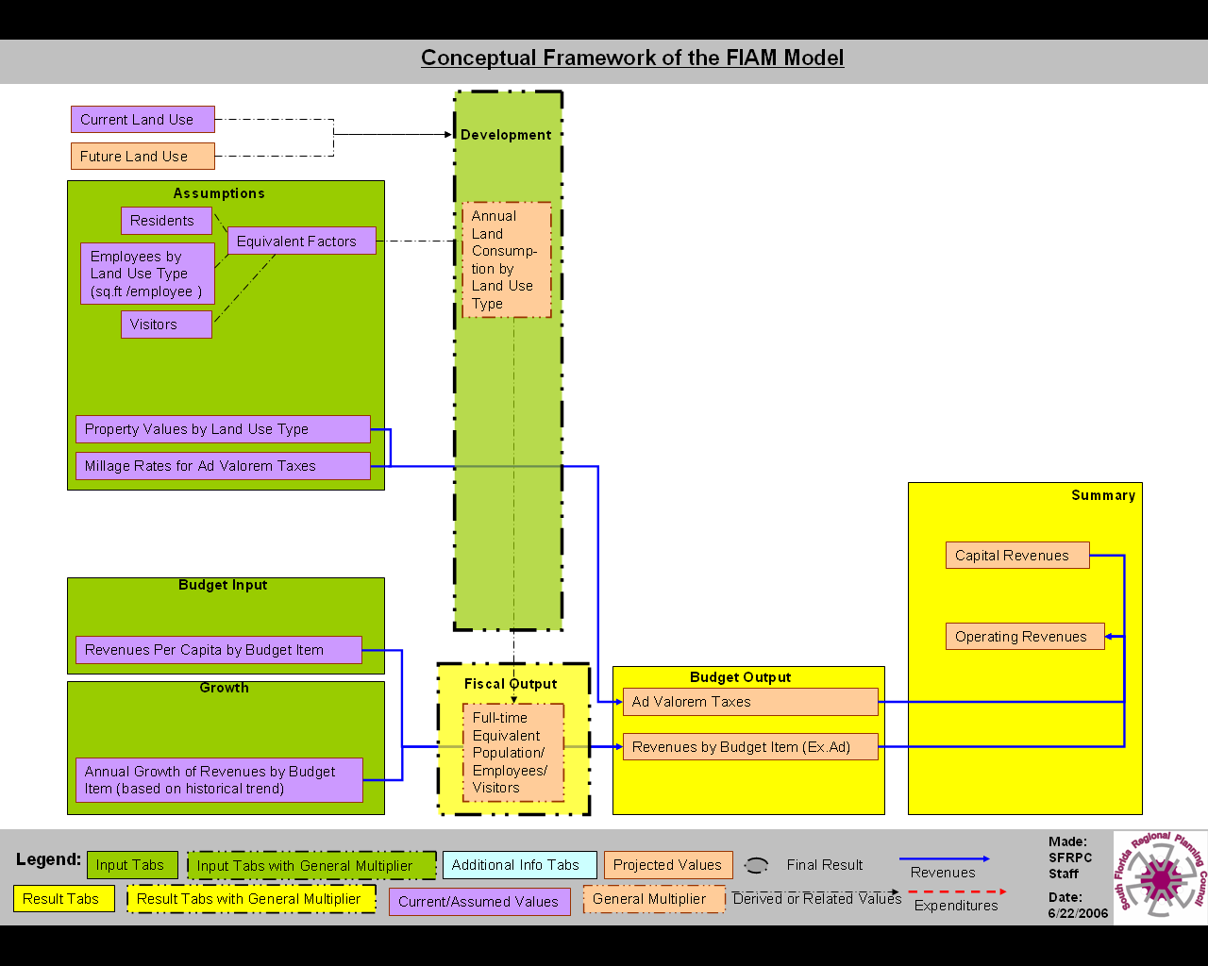

- Click to clean all unnecessary boxes on the screen. Then click three times to show how to calculate the combined Present Value with Capital Revenues, Capital Costs, Operating Revenues and Operating Costs, all brought together on the Summary tab.

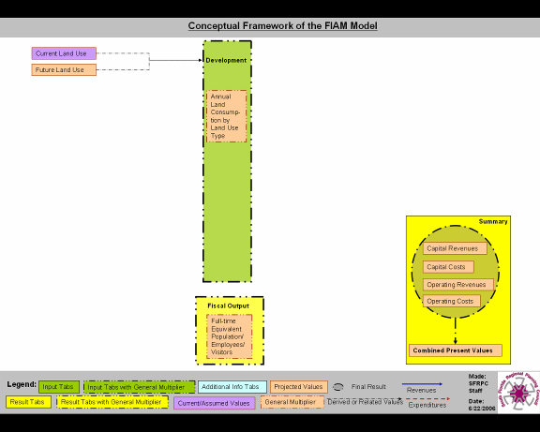

- One final click will show all the elements we have explored earlier. Ask if there are any questions.



